Explore the world

Once you find your top picks from the quotes listed below, make sure to put them to use. Consider creating something special that will help you keep your favorite [travel memories](https://www.shutterfly.com/travel/) alive with the project ideas below:

* [Luggage Tag](https://www.shutterfly.com/t/luggage-tags): Make custom luggage tags for you and the family that highlight exactly how much you’re ready to hop on a plane.
* [Travel Gifts](https://www.shutterfly.com/travel/): Personalized gifts and keepsakes make perfect opportunities to highlight your favorite travel quotes.
* [Travel Photo Books](https://www.shutterfly.com/t/photo-book-styles/?theme=Travel): Once you’re ready to fill the pages of a photo book with all your favorite vacation photos, consider adding a few of your top quote picks for captions!
* [Kids Travel Essentials](https://www.shutterfly.com/kids/travel): Check out our kids travel essentials and customize your favorites with fun family photos from your last vacation.

Funny Travel Quotes

These travel quotes are as hilarious as they are true. Pick your favorite to send to a friend or to use in your next Instagram caption.

[](https://www.shutterfly.com/travel/)

* “I haven’t been everywhere, but it’s on my list.” – Susan Sontag
* “Work, Travel, Save, Repeat.” – Unknown
* “When preparing to travel, lay out all your clothes and all your money. Then take half the clothes and twice the money.” – Susan Heller
* “Can we just skip to the part of my life where I travel the world?” – Unknown
* “Vacation calories don’t count. Right?” – Unknown
* “I want someone to look at me the way I look at a travel magazine.” – Unknown
* “I need six months of vacation, twice a year.” – Unknown
* “The worst thing about being a tourist is having other tourists recognize you as a tourist.” – Russell Baker
* “I’ve been to almost as many places as my luggage.” – Bob Hope
* “Travel becomes a strategy for accumulating photographs.” – Susan Sontag

Inspirational Travel Quotes

These inspirational travel quotes will remind you of the transformational experience traveling can be. They also look great on a [travel mug](https://www.shutterfly.com/t/travel-mugs/).

[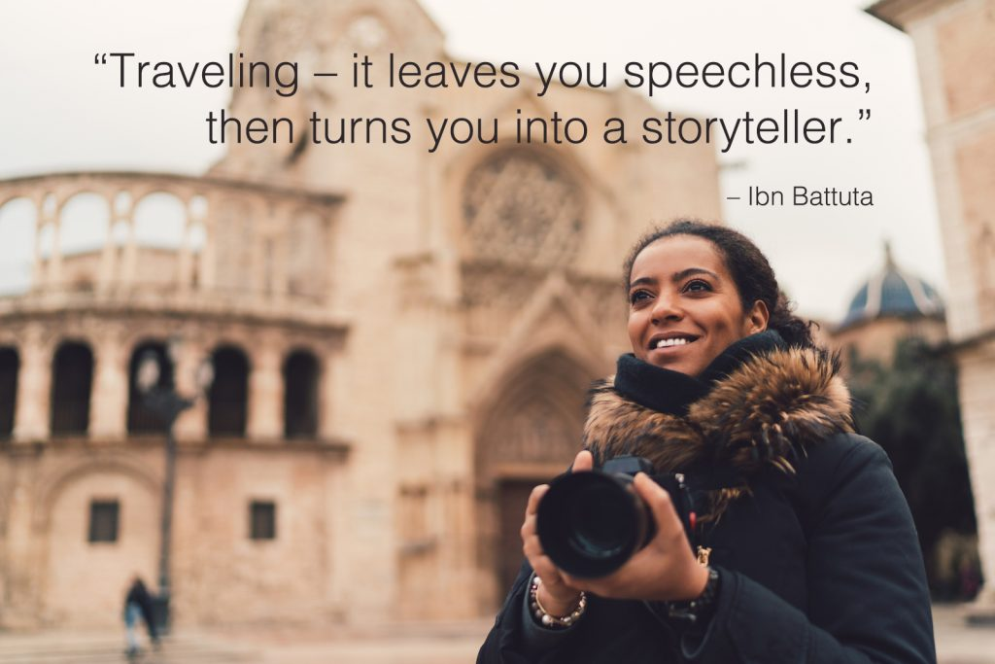](https://www.shutterfly.com/travel/)

* “Man cannot discover new oceans unless he has the courage to lose sight of the shore.” – Andre Gide
* “Remember that happiness is a way of travel – not a destination.” – Roy M. Goodman
* The most beautiful in the world is, of course, the world itself.” – Wallace Stevens
* “Traveling – it leaves you speechless, then turns you into a storyteller.” – Ibn Battuta
* “We live in a wonderful world that is full of beauty, charm and adventure. There is no end to the adventures we can have if only we seek them with our eyes open.” – Jawaharial Nehru
* “Perhaps travel cannot prevent bigotry, but by demonstrating that all peoples cry, laugh, eat, worry, and die, it can introduce the idea that if we try and understand each other, we may even become friends.” – Maya Angelou
* “A person susceptible to ‘wanderlust’ is not so much addicted to movement as committed to transformation.”  – Pico Iyer
* “We travel, some of us forever, to seek other states, other lives, other souls.” – Anais Nin
* “I travel not to go anywhere, but to go. I travel for travel’s sake. The great affair is to move.” – Robert Louis Stevenson

Short Travel Quotes

They’re short, they’re sweet, and they’re oh-so-true. These short travel quotes will have you wanting to be back on a beach in no time.

[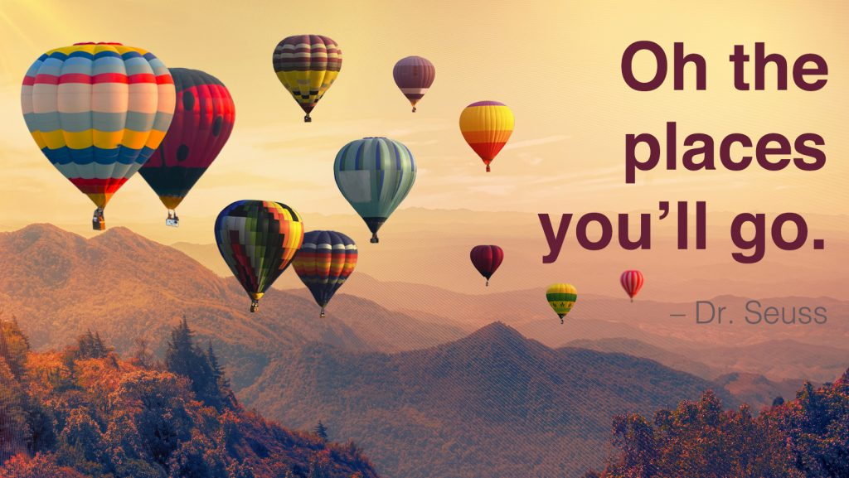](https://www.shutterfly.com/travel/)

* “Jobs fill your pocket, but adventures fill your soul.” – Jamie Lyn Beatty
* “To Travel is to Live.” – Hans Christian Andersen
* “Life is either a daring adventure or nothing at all.” – Helen Keller
* “Blessed are the curious for they shall have adventures.” – Lovelle Drachman
* “Take only memories, leave only footprints.” – Chief Seattle
* “Live your life by a compass not a clock.” – Stephen Covey
* “Not all those who wander are lost.” – J.R.R. Tolkien
* “Oh the places you’ll go.” – Dr. Seuss
* “Adventure is worthwhile.” – Aesop
* “Life is short and the world is wide.” – Unknown
* “A journey of a thousand miles begins with a single step.” – Lao Tzu

Famous Travel Quotes

These famous minds knew exactly how addicting travel can be, and we want to share their insights with you.

[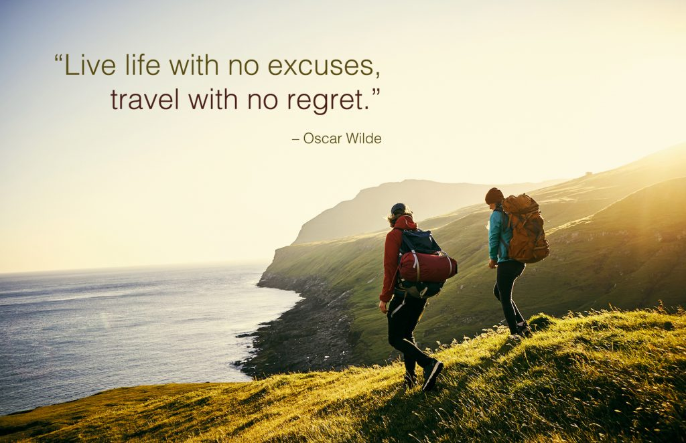](https://www.shutterfly.com/travel/)

* “It is not down in any map; true places never are.” – Herman Melville
* “I’m in love with cities I’ve never been to and people I’ve never met.” – John Green
* “The world is a book and those who do not travel read only one page.” – Augustine of Hippo
* “Live life with no excuses, travel with no regret.” – Oscar Wilde
* “Once a year, go someplace you’ve never been before.” – Dalai Lama
* “People don’t take trips, trips take people.” – John Steinbeck
* “A good traveler has no fixed plans, and is not intent on arriving.” – Lao Tzu
* “The world makes way for the man who knows where he is going.” – Ralph Waldo Emerson
* “It’s not what you look at that matters. It’s what you see.” – Henry David Thoreau
* “Two roads diverged in a wood and I – I took the one less traveled by, and that has made all the difference.” – Robert Frost

Mark Twain Travel Quotes

* “Twenty years from now you will be more disappointed by the things that you didn’t do than by the ones you did do. So throw off the bowlines. Sail away from the safe harbor. Catch the trade winds in your sails. Explore. Dream. Discover.” – Mark Twain
* “Travel is  fatal to prejudice, bigotry, and narrow mindedness, and many of our people need it sorely on these accounts.” – Mark Twain
* “I have found out that there ain’t no surer way to find out whether you like people or hate them than to travel with them.” – Mark Twain
* “It liberates the vandal to travel — you never saw a bigoted, opinionated, stubborn, narrow-minded, self-conceited, almighty mean man in your life but he had stuck in one place since he was born and thought God made the world and dyspepsia and bile for his especial comfort and satisfaction.” – Mark Twain

Anthony Bourdain Travel Quotes

* “Travel isn’t always pretty. It isn’t always comfortable. Sometimes it hurts, it even breaks your heart. But that’s okay. The journey changes you; it should change you. It leaves marks on your memory, on your consciousness, on your heart, and on your body. You take something with you. Hopefully, you leave something good behind.” – Anthony Bourdain
* “If you’re twenty-two, physically fit, hungry to learn and be better, I urge you to travel – as far and as widely as possible. Sleep on floors if you have to. Find out how other people live and eat and cook. Learn from them – wherever you go.” – Anthony Bourdain
* “It seems that the more places I see and experience, the bigger I realize the world to be. The more I become aware of, the more I realize how relatively little I know of it, how many places I have still to go, how much more there is to learn.” – Anthony Bourdain
* “Travel is about the gorgeous feeling of teetering in the unknown.” – Anthony Bourdain

Travel Alone Quotes

Do you love solo travel? If so, these adventure quotes were made just for you. And don’t be afraid to share them with other fellow travelers who don’t mind the occasional solo adventure.

[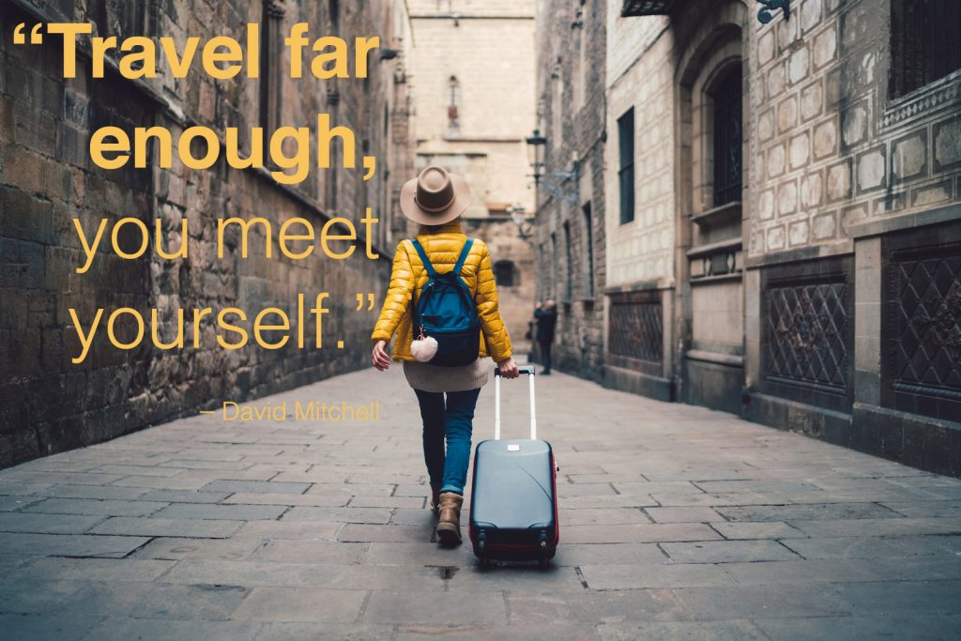](https://www.shutterfly.com/travel/)

* “A ship in a harbor is safe, but it not what ships are built for.” – John A. Shedd
* “Travel makes one modest. You see what a tiny place you occupy in the world.” – Gustav Flaubert
* “Travel far enough, you meet yourself.” – David Mitchell
* “Adventure is a path. Real adventure, self-determined, self-motivated, often risky, forces you to have firsthand encounters with the world.” – Mark Jenkins
* “Traveling is a brutality. It forces you to trust strangers and to lose sight of all that familiar comfort of home and friends. You are constantly off balance. Nothing is yours except the essential things: air, sleep, dreams, sea, the sky – all things tending towards the eternal or what we imagine of it.” – Cesare Pavese
* “To awaken quite alone in a strange town is one of the pleasantest sensations in the world.” – Freya Stark
* “Travel only with thy equals or thy betters; if there are none, travel alone.” – The Dhammapada

Travel Together Quotes

Whether it’s with your Dad, your sister, your friend, or your significant other– these travel together quotes are sure to remind you of all the wonderful memories you shared together.

[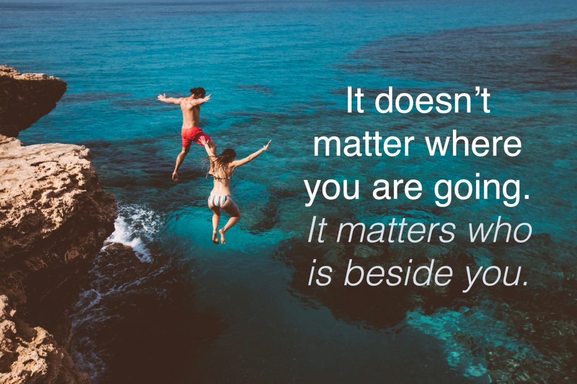](https://www.shutterfly.com/travel/)

Couple Travel Quotes

* “I would like to travel the world with you twice. Once to see the world. Twice, to see the way you see the world.” – Anonymous
* “It doesn’t matter where you are going. It matters who is beside you.” – Anonymous
* “Will you give me yourself? Will you come travel with me? Shall we stick by each other as long as we live?” – Walt Whitman
* “What we find in a soul mate is not something to tame, but something wild to run with.” – Robert Brault
* “Go the distance, couples who travel together are more likely to stay together and feel more connected.” – Anonymous
* “Here’s to all the places we went. And here’s to all the places we ‘ll go. And here’s to me, whispering again and again and again and again: I love you.” – Anonymous

Family Travel Quotes

* “When traveling with someone, take large doses of patience and tolerance with your morning coffee.” – Helen Hayes
* “As soon as I saw you, I knew an adventure was about to happen.” – A. A. Milne, Winnie the Pooh
* “Actually, the best gift you could have given her was a lifetime of adventures” – Lewis Carroll
* “It’s a magical world, Hobbes, ol’ buddy… Let’s go exploring!” – Calvin from Calvin and Hobbes
* “The greatest legacy we can leave our children is happy memories” – Og Mandino

Travel With Friends Quotes

* “A journey is best measured in friends rather than miles.” – Tim Cahill
* “Good company in a journey makes the way seem shorter.” – Izaak Walton
* “The more I traveled the more I realized that fear makes strangers of people who should be friends.” – Shirley MacLaine
* “I get a friend to travel with me… I need somebody to bring me back to who I am. It’s hard to be alone.” – Leonardo DiCaprio
* “Sharing adventures means enjoying them 100% more.” – Anonymous
* “Friends that travel together, stay together.” – Anonymous